IoT Devices
# Source: AI Source: Provided by: [Data Path: Persons Table -> ID Column: 1, Name_En Column: Motasem Essam] -> From: [ChatGPT] on [1/23/2026]
IoT Devices (Internet of Things Devices) are physical objects connected to the internet that can collect, send, and receive data. These devices use sensors, software, and connectivity to interact with other devices or systems — often without human involvement.

Common IoT Image
# Source: Table Source: Provided by: [Data Path: Persons Table -> ID Column: 1, Name_En Column: Motasem Essam] From: [Data Path: Miscellaneous Folder -> Miscellaneous Database -> Miscellaneous Table -> ID: 35] on [1/23/2026]
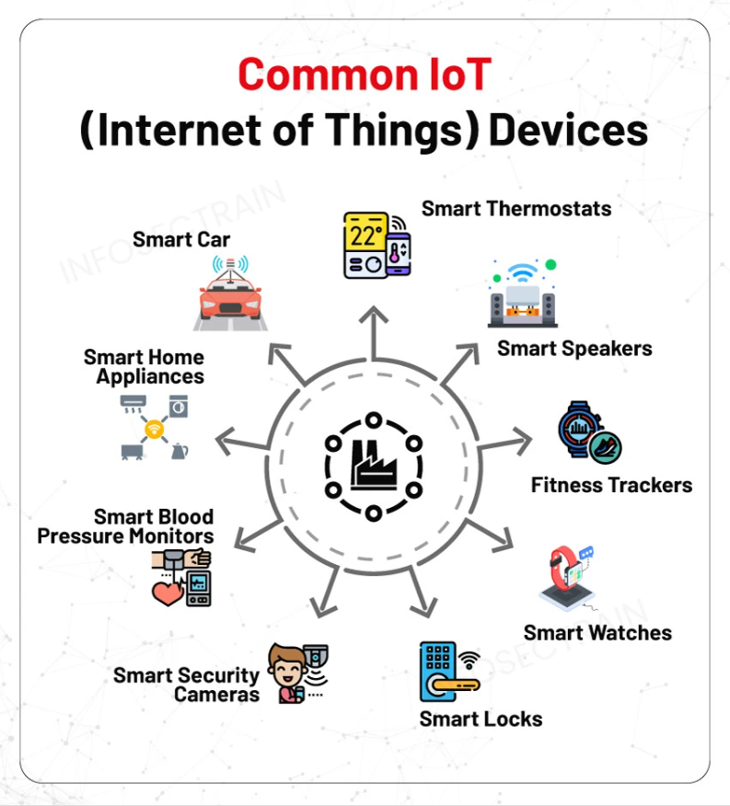

🌐 What "Internet of Things" (IoT) Means:
# Source: AI Source: Provided by: [Data Path: Persons Table -> ID Column: 1, Name_En Column: Motasem Essam] -> From: [ChatGPT] on [1/23/2026]
- "Things" = everyday objects (e.g. watches, fridges, thermostats).
- Connected to the Internet = can share data.
- Smart = can monitor, control, or automate tasks.

🔑 Key Features of IoT Devices:
# Source: AI Source: Provided by: [Data Path: Persons Table -> ID Column: 1, Name_En Column: Motasem Essam] -> From: [ChatGPT] on [1/23/2026]
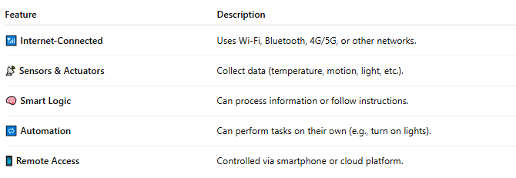

Feature | Description
📶 Internet-Connected | Uses Wi-Fi, Bluetooth, 4G/5G, or other networks.
📡 Sensors & Actuators | Collect data (temperature, motion, light, etc.).
🧠 Smart Logic | Can process information or follow instructions.
🔁 Automation | Can perform tasks on their own (e.g., turn on lights).
📱 Remote Access | Controlled via smartphone or cloud platform.

🧩 Examples of IoT Devices:
# Source: AI Source: Provided by: [Data Path: Persons Table -> ID Column: 1, Name_En Column: Motasem Essam] -> From: [ChatGPT] on [1/23/2026]
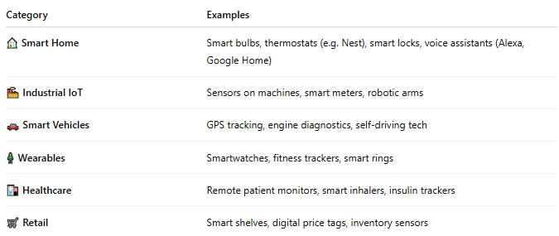

Category | Examples
🏠 Smart Home | Smart bulbs, thermostats (e.g. Nest), smart locks, voice assistants (Alexa, Google Home)
🏭 Industrial IoT | Sensors on machines, smart meters, robotic arms
🚗 Smart Vehicles | GPS tracking, engine diagnostics, self-driving tech
🧍 Wearables | Smartwatches, fitness trackers, smart rings
🏥 Healthcare | Remote patient monitors, smart inhalers, insulin trackers
🛒 Retail | Smart shelves, digital price tags, inventory sensors

💡 How IoT Works (Basic Flow):
# Source: AI Source: Provided by: [Data Path: Persons Table -> ID Column: 1, Name_En Column: Motasem Essam] -> From: [ChatGPT] on [1/23/2026]
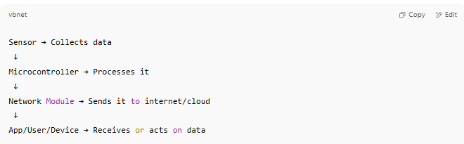

Sensor → Collects data
↓
Microcontroller → Processes it
↓
Network Module → Sends it to internet/cloud
↓
App/User/Device → Receives or acts on data

📖 Summary:
# Source: AI Source: Provided by: [Data Path: Persons Table -> ID Column: 1, Name_En Column: Motasem Essam] -> From: [ChatGPT] on [1/23/2026]
IoT devices are smart, connected physical objects that gather and exchange data to automate processes, increase efficiency, or enhance everyday life. They’re everywhere — in homes, cars, hospitals, factories, and even on our bodies.

